Application: Ribbon
Revit Platform: All
Revit Version: 2011.0
First Released For: 2010.0
Programming Language: C#
Skill Level: Beginning
Category: Basics
Type: ExternalApplication

Subject: Create customized Ribbon by Ribbon API
Summary:
This sample demonstrates how to create customized ribbon for Add-In and how to create different types of ribbon items (RibbonPanel, PushButton, PulldownButton, Stackable Buttons, RadioButtonGroup, TextBox, SplitButton).

Classes:

Autodesk.Revit.ApplicationServices.ControlledApplication
Autodesk.Revit.UI.RibbonPanel
Autodesk.Revit.UI.PushButton
Autodesk.Revit.UI.PulldownButton
Autodesk.Revit.UI.PushButtonData
Autodesk.Revit.UI.PulldownButtonData
Autodesk.Revit.UI.IExternalCommand
Autodesk.Revit.UI.IExternalApplication

Project Files:

RibbonSample.cs
This file contains the class RibbonSample which inherited from interface IExternalApplication and implemented method OnStartUp. The class will add some customized ribbon buttons with some simple functions attached to each of them. And these functions will be implemented in the AddInCommands class.

AddInCommands.cs
This file contains several classes named CreateWall, CreateStructuralWall, DeleteWalls, XMoveWalls, YMoveWalls. These classes are corresponding to the buttons which created on ‘Add-In’ Ribbon panels.

Description
This sample should provide the following functionalities:
• Add different kinds of Ribbon Buttons into Revit: (just like the screenshot below)
➢ First Part of the Panel is use to create walls or structural walls.
➢ Second Part is used to select on which level the new wall with what shape will be built. Also, you can undo you changes made on those choosing by “Reset” button.
➢ Third Part is used to select the wall type.
➢ Fourth Part is used to set the “Mark” of the new wall.
➢ Fifth Part is used to delete or move walls.
➢ Fourth and fifty parts are added into the Slide-Out panel.

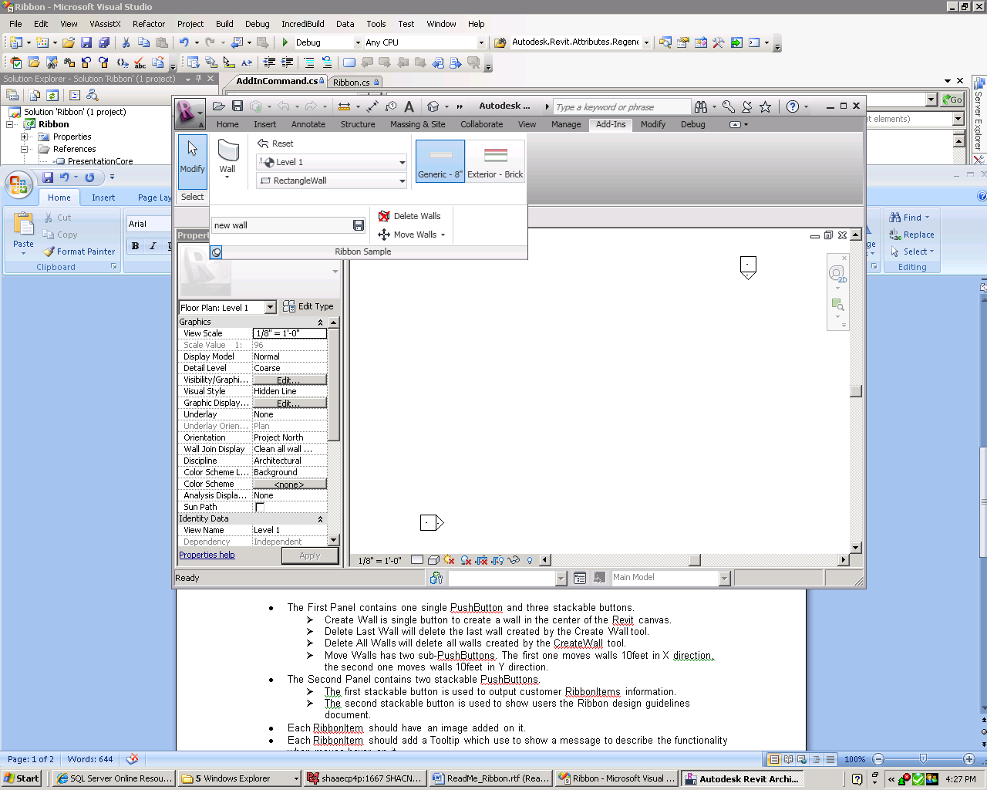
• The First Part contains one SplitButton which consists with two PushButtons.
➢ Create Wall is used to create a wall in the center of the Revit canvas.
➢ Create Wall is used to create a structural wall in the center of the Revit canvas.
• The Second Part contains one StackedButton which is consisted of one PushButton and two Comboboxes.
➢ The first button is used to reset the choosing changes made by user.
➢ The other two Combo-boxes are used to select the level and wall’s shape.
• The Third Part contains a RadioButtonGroup for user to select WallType.
• The Fourth Part contains a Text box which is used to set the “Mark” for the new wall.
• The Fifth Part contains a StackedButton which consisted of a PushButton (delete all the walls) and a PulldownButton (move all the walls in X or Y direction)

Implementation Notes
• To add RibbonPanel in Revit, user need to implement the IExternalApplication interface, and call the corresponding method to create RibbonItems in OnStartup(ControlledApplication) method.
• Each button in every Panel should have a corresponding command to execute. The command corresponding to each button should implement the IExternalCommand interface.
• Use ControlledApplication.CreateRibbonPanel(string ribbonName) to add new Panel to Revit.
• Use RibbonPanel.AddPushButton() to add single PushButton to each Panel.
• Use RibbonPanel.AddStackedButtons() to add stackable buttons to each panel.
• Use PulldownButton.AddItem() to add sub button to each PulldownButton.
• Set the Image or LargeImage properties, user must new an ImageSource class first, but ImageSource is an abstract class, so user must new the subclass of ImageSource, such as BitmapImage.
For instance: PushButton.Image = new BitmapImage(new Uri(imagePath, UriKind.Absolute))

Instructions:
1. Copy .addin file to the corresponding Addins folder for the Revit. You can found out the location of this folder by RevitAddUtility.dll, we also provided a sample named ExternalCommand for it.
(For example, folder location for XP user is here: \\Documents and Settings\All Users\Application Data\Autodesk\Revit\Addins\2012)
2. Copy the Ribbon.dll and image files (bmp) to the same directory of this sample dll.
3. Run Revit, then you can see the customized ribbon panel in Revit.
4. Click each button to run this sample.
• Click the ‘Structural Wall’ PushButton several times to create some walls in Revit.
• Click on Combo-box and RadioButtonGroup to select what kind of wall you want to create.
• Click the ‘Delete Walls’ button will delete all the walls created by Create Wall command.
• Click the two sub buttons in the ‘Move Walls’ PulldownButton to move the wall.

